**LAB # 10**

**Working with Microsoft Access**

## **Introduction**

Microsoft Access is a DBMS (also known as Database Management System) from Microsoft. It is a member of the Microsoft Office suite of applications, included in the Professional and higher editions or sold separately.Microsoft Access stores data in its own format based on the Access Database Engine.

Software developers and data architects can use Microsoft Access to develop application software, and "power users" can use it to build software applications. Like other Office applications, Access is supported by Visual Basic for Applications (VBA), an object-based programming language that can reference a variety of objects including DAO (Data Access Objects), ActiveXData Objects, and many other ActiveX components. Visual objects used in forms and reports expose their methods and properties in the VBA programming environment, and VBA code modules may declare and call Windows operating-system functions.

### Understanding tables

All tables are composed of horizontal **rows** and vertical **columns**, with small rectangles called **cells** in the places where rows and columns intersect. In Access, rows and columns are referred to as **records** and **fields**

.

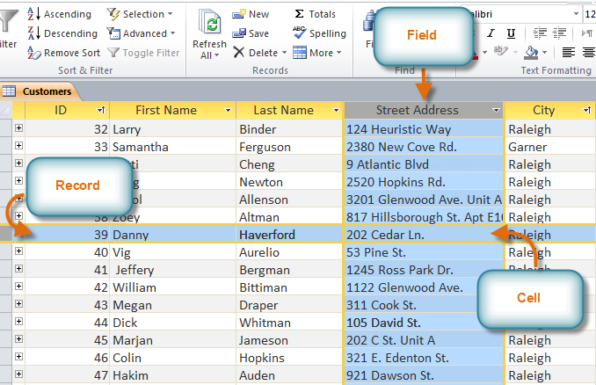

A **field** is a way of organizing information by type. Think of the **field name** as a question, and every cell within that field as a response to that question.

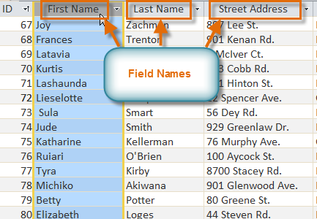

A **record** is one unit of information. Every cell on a given row is part of that row's record. Each record has its own**ID number**. Within a table, each ID number is unique to its record and refers to all of the information within that record. The ID number for a record cannot be changed.

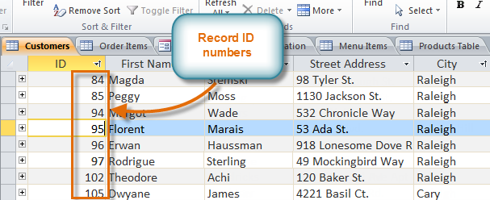

Each cell of data in your table is part of both a **field** and a **record**. For instance, if you had a table of names and contact information, each person would be represented by a record, and each piece of information about each person—name, phone number, address, and so on—would be contained within a distinct field on that record's row.

**Creating a Database Table**

Let’s create a table of student records using Access. Open Access the Access window should display a Blank Database button as shown in Figure below.

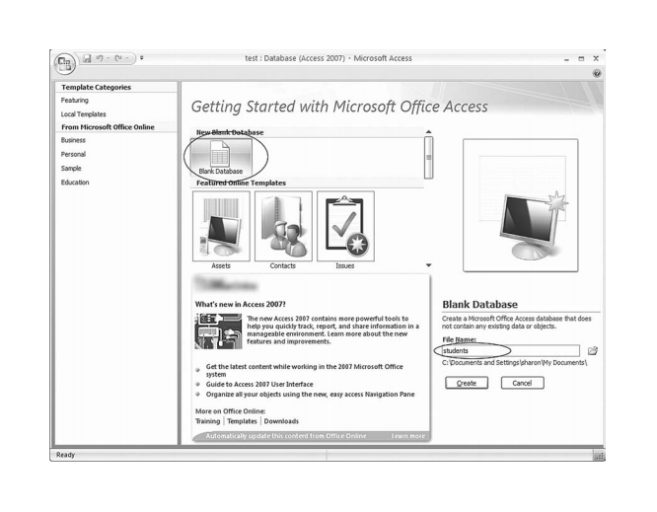

Click the Create button to create the blank database. Access will display an empty table as shown in Figure

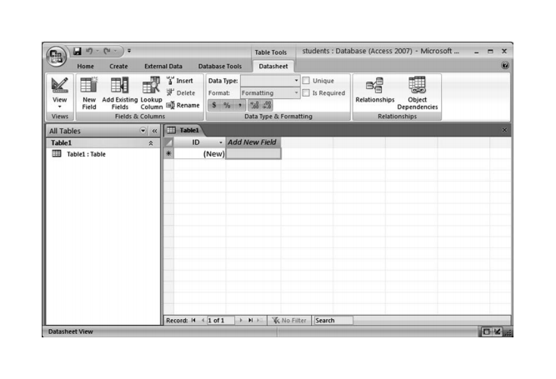

Click the View button and click the option Design View.

The Save As dialog box will appear. In the Save As dialog box type: grades Click the OK button to save the table.

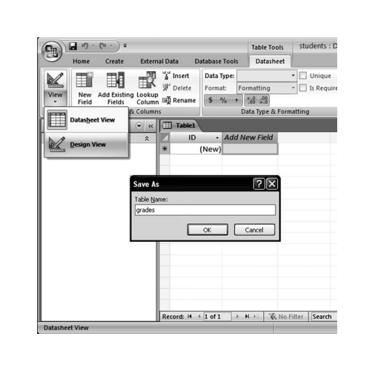

**Set Fields**

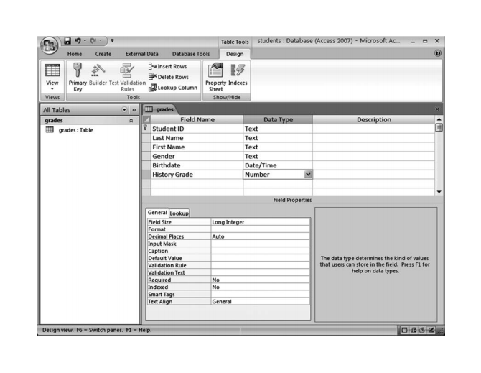

**Data Types**

We will store the Student ID as a text field there are a variety of data types available. Other database programs may have some of these data types and some additional data types, but the general concept is the same. A field will contain items that are all of the same type of data. For instance, a field of first names will contain text items and a field of birthdates will contain items that are all dates. Access supports the following data types.

**Text**: Use this data type for data that contains alphabetic characters or a combination of letters, numbers, and special characters. Examples include last name, street address, and phone number. It can also be used for data that contains only numbers, such as a credit card number or employee number when the number will not be used in mathematical calculations. The text data type stores up to 255 characters.

**Memo**: Use this data type for lengthy text data when the text data type is not suitable. The memo data type is suitable for a comment or description field and stores up to 63,999 characters.

**Number**: Use this data type for values that will be used for mathematical calculations.

**Date/Time**: Use this data type for dates and times. Currency: Use this data type for values that represent money. The currency data type will prevent rounding errors of fractions of a cent.

**Yes/No**: Use this data type when the data has only two possible values. The values could be yes/no, true/false or on/off

The default field size of **shortText** is 255 characters. We will change the field size to 10. Choosing the smallest appropriate field size will save storage space for the table. This also restricts the data entry to 10 characters, which minimizes data entry errors. The user will not be able to enter more than 10 characters

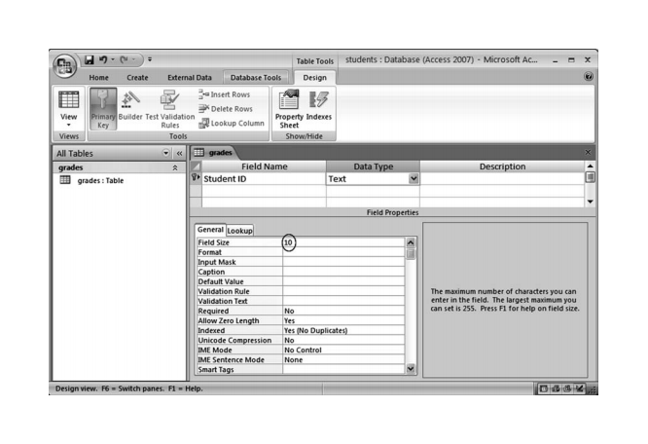

You may have noticed the key symbol to the left of the Student ID field name. Access grades table showing primary key icon.

A **primary** key is a field that contains unique data so that there are no duplications. This field can be used to identify each record. In the case of the grades table, the Student ID field contains data items that would be unique. No two students would have the same Student ID. It is not necessary for a table to have a primary key.

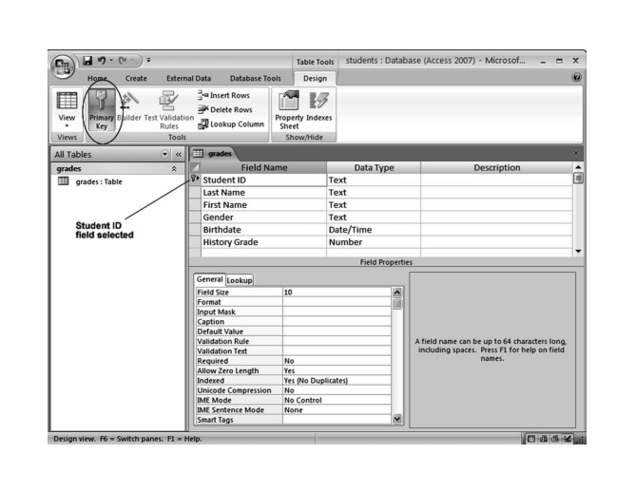

Now that we’ve created the structure of the table, we can add records. To do this, we will switch from Design View to Datasheet View. Click the View button and select the Datasheet View menu option. Click the Datasheet View menu option, as shown in

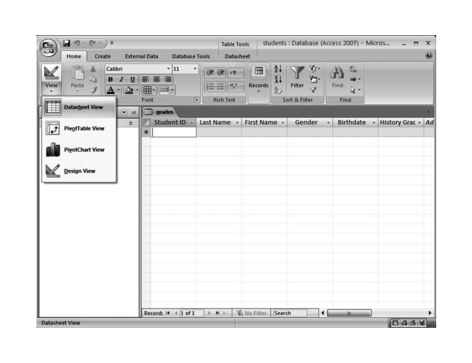

**Creating a Form**

A form is a database object that is used to enter or display data in a database.

**To Create a Form:**

Open the table or query on which you are basing the form

Click on the **Create** tab

Click on **Form** in the **Forms** group

A form is created and opens in Layout View.

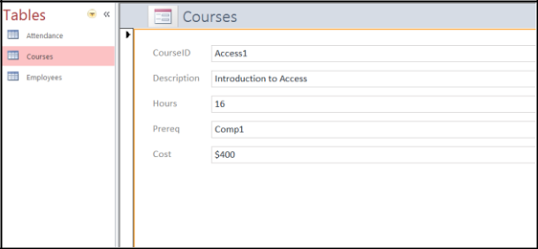

**Different Views:**

**Form View** –this view allows you to view, create and edit records

**Layout View** - this view is similar to Design View but is more visually-oriented in that eachcontrol displays real data. As a result, this is a very useful view for setting the size of controls, or performing many other tasks that affect the visual appearance and usability of the form. **Design View** - this view gives you a more detailed view of the structure of the form. You cansee the header, detail, and footer sections for the form. You cannot see the underlying data while you are making design changes.

**Reports**

Reports can be based on tables or queries.

**To Create a Report:**

1. Open the table or query on which you are basing the report
2. Click on the **Create** tab
3. Click on **Report** in the **Reports** group

A report is created in Layout View.

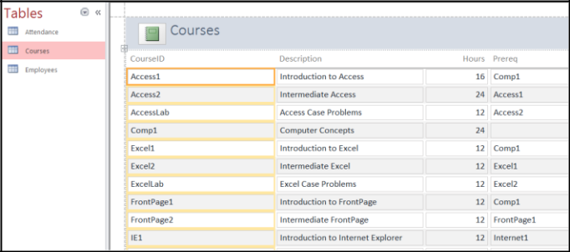

**Printing Reports**

**To Print a Report:**

1. Switch to **Print Preview** from **View** on the **Design** tab under **Report Layout Tools**
2. Click the **Print** icon
3. Click on **OK**

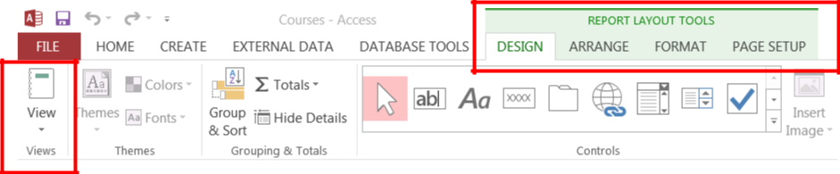

## **Lab Tasks**

**Task # 01:** Create following table:

**Table Name:** Faculty

**Column 1:** Faculty_Id (AutoNumber) PK

**Column 2:** Name (Short Text)

**Column 3:** Designation (Short Text)

**Column 4:** Contact No (Number)

**Column 5:** City (Lookup Wizard)

**Column 5:** Dept_Name (Lookup Wizard)

**Column 6:** Picture (Attachment)

Insert three records into this table and save the results.

**Task # 02:** Create a form for inserting Faculty details in Access Database. **Table Name:** Faculty.

**Task # 03:** Create suitable report of the given database that shows all the records stored in the table.